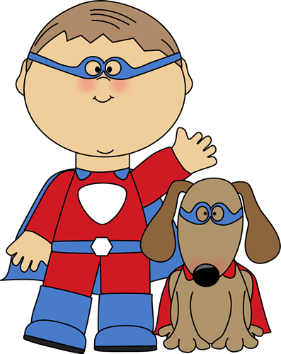

1. Supermarkets ______________ (open) at 8 o’clock and

__________________(close) at 9.

1. Yesterday I _______________(buy) a T-shirt and cargo shorts.
2. They ____________________(have) dinner when the tornado _________________(strike).
3. By next summer Jayden _________________ (complete) the

beginner’s computer course.

1. I _________________(lie) on the beach in Ibiza this time next week. Lucky me!
2. Every morning Jackson ____________ (turn) on his computer and _______________ (check) his Facebook for updates and news.
3. Sophia and Isabella _______________ (not/finish) their power point presentation on African animals yet.
4. Tonight Evan ______________________(play) a game of singles with his best friend, Christopher.
5. This summer I _________________(read) 10 classic novels for school.
6. Ethan and Noah ________________(already/wait) for 2 hours, when the bus finally ________________ (arrive).
7. What _________________ (you/do) this weekend? I think I _____________ (start) a new jigsaw puzzle.
8. Mia looks very pale. It looks like she ________________________(faint).
9. My cousins, Logan and Jackson, _____________________(live) in Barcelona since 2006.
10. My Uncle Landon ________________________ (work) in Dublin from 2002-2008.
11. My mother and father _______________________(paint) the kitchen all morning.
12. Right now Cameron ______________________ (play) his favorite computer game.
13. What _____________________ (you/do) at the moment? Oh, nothing.
14. This is the first time I ____________________ (ever/try) snails.





19. Fortunately Abigail _______________ just/ (put up) her umbrella when it ______________(start) to pour. Or she would have been soaked.

20. Last night my family and I __________________(watch) an interesting

documentary on Ancient Greece.

21. Andrew _____________________(never/be) on a safari before and he is so excited.

22. Tomorrow morning I ____________________(see) my dentist for my yearly checkup.

23. Real Madrid _______________________________ (play) against Barcelona tonight.

24. Our school ___________________(usually/have) breaks in the morning and afternoon.

25. That girl with the red hair _______________________(talk) on the phone right now.

26. Natalie _________________________(sleep ) over Chloe’s house last Saturday night.

27. I ______________________(not/often go) to the cinema these days. _______ you ________ (go) to the cinema once a month?

28. Guess what I _________________ (wear) to the party last night? A vampire costume.

29. By next June, they _____________________________(graduate) from high school.

30. What __________________(you/do) while the ground _________________(shake) during the earthquake?

31. We ______________ (drive) on Main Street when a dog __________ (run) in front of our car.

32. Our flight _________________(leave) at 9 in the morning.

33. Bad weather ____________ (delay) our flight to Madagascar last summer.

34. School ____________(start) in September and ________________ (finish) in June.

25. Where __________________ (go) this summer? I ________________(go) on a trek in the Himalayas.

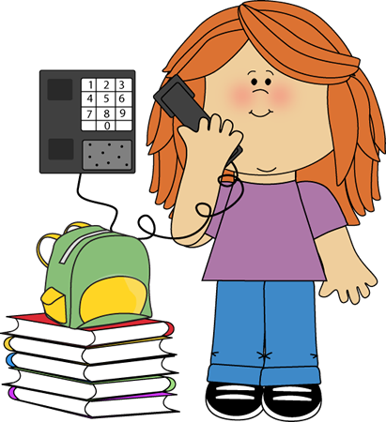





1. Supermarkets open (open) at 8 o’clock and close (close) at 9.

2.Yesterday I bought(buy) a T-shirt and cargo shorts.

3.They were having (have) dinner when the tornado struck (strike).

4.By next summer Jayden will have completed (complete) the

beginner’s computer course.

5.I will be lying (lie) on the beach in Ibiza this time next week. Lucky me!

6.Every morning Jackson turns (turn) on his computer and checks (check) his Facebook for updates and news.

7.Sophia and Isabella haven’t finished (not/finish) their power point presentation on African animals yet.

8.Tonight Evan is playing (play) a game of singles with his best friend, Christopher.

1. This summer I am going to read (read) 10 classic novels for school.

10.Ethan and Noah had already been waiting(had already waited) (already/wait) for 2 hours, when the bus finally arrived (arrive).

11.What are you doing (you/do) this weekend? I think I

I’ll start (start) a new jigsaw puzzle.

12.Mia looks very pale. It looks like she is going to faint(faint).

13.My cousins, Logan and Jackson, have lived(live) in Barcelona since 2006.

14.My Uncle Landon worked (work) in Dublin from 2002-2008.

15.My mother and father have been painting(paint) the kitchen all morning.

16.Right now Cameron is playing (play) his favorite computer game.

17.What are you doing (you/do) at the moment? Oh, nothing.

18.This is the first time I have ever eaten (ever/try) snails.

19. Fortunately Abigail had just opened just/ (open) her umbrella when it started (start) to pour. Or she would have been soaked.

20. Last night my family and I watched (watch) an interesting

documentary on Ancient Greece.

21. Andrew has never been (never/be) on a safari before and he is so excited.

22. Tomorrow morning I am seeing (see) my dentist for my yearly checkup.

23. Real Madrid is playing (play) against Barcelona tonight.

24. Our school usually has (usually/have) breaks in the morning and afternoon.

25. That girl with the red hair is talking (talk) on the phone right now.

26. Natalie is going to sleep (sleep ) over Chloe’s house last Saturday night.

27. I don’t often go (not/often go) to the cinema these days. Do you go (go) to the cinema once a month?

28. Guess what I am wearing (wear) to the party last night? A vampire costume.

29. By next June, they will have graduated (graduate) from high school.

30. What were you doing (you/do) while the ground was shaking (shake) during the earthquake?

31. We were driving (drive) on Main Street when a dog ran (run) in front of our car.

32. Our flight leaves (leave) at 9 in the morning.

33.Bad weather delayed our flight to Madagascar last summer (delay)

34. School starts (start) in September and finishes (finish) in June.

25. Where are you going (go) this summer? I am going (go) on a trek in the Himalayas.